**Upgrades and changes in Staff**

**SAU Search functionality:**

1. A new column named “Position Status” added to the grid to display the collective status of the staff member.
   1. If all the positions for a staff member are “Active” then the “Positions Status” shall be displayed as Active.
   2. If at least one of the positions for a staff member is “In Progress” then the “Position Status” shall display InProgress with total number of positions in progress listed in parentheses.

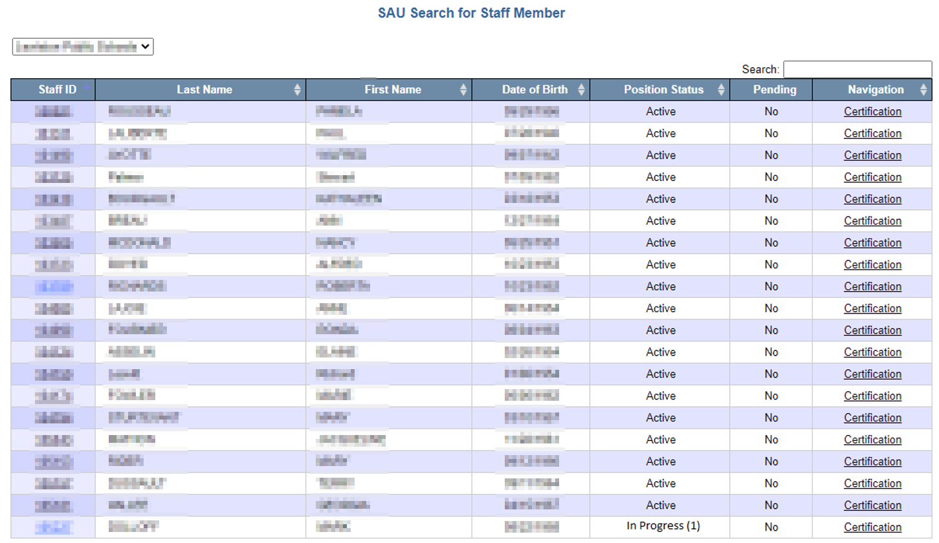

**Staff Member Details:**

1. In Progress status added to the list of Assignment Status.
   1. Selection of In Progress from the dropdown shall display the number of in progress positions (if any) only.

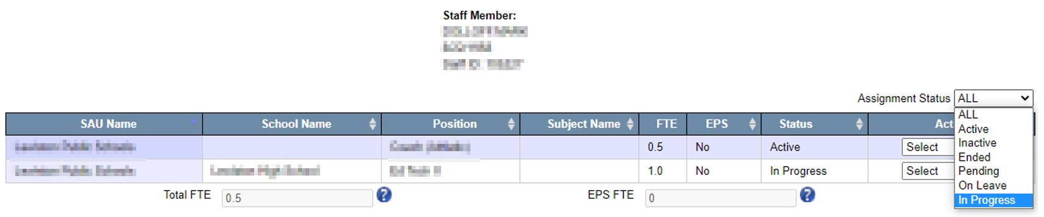

1. All the “Active” position status shall be changed to In Progress position status when the End of Year job is run.
2. All other logic in the staff details grid remains unchanged.

**Staff Member Assignment:**

1. Save button added to the edit assignment screen, which can be accessed by selecting “Edit” from the dropdown for actions for each position.
   1. If the user clicks on “Save” button, system shall save any edits made to assignment without any validations in the backend.
   2. For any position, if the status was “Active” and the user edits and saves the assignment with any information, then the new status of “In Progress” shall be displayed.
   3. For any position, if the status was “In Progress” and the user edits and saves the assignment with any information, then the status of “In Progress” shall be displayed.

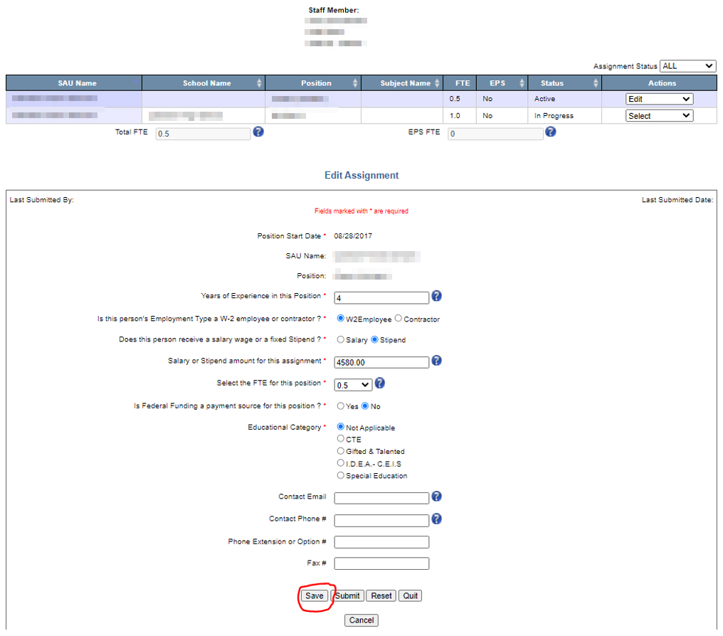

1. Last Updated By and Last Updated Date is replaced by Last Submitted By and Last Submitted Date.
   1. The two new fields of Last Submitted By and Last Submitted Date shall be blank for all the districts until the data in the new year is submitted.
   2. System shall display the name of the user and the time stamp when the assignment changes were submitted.

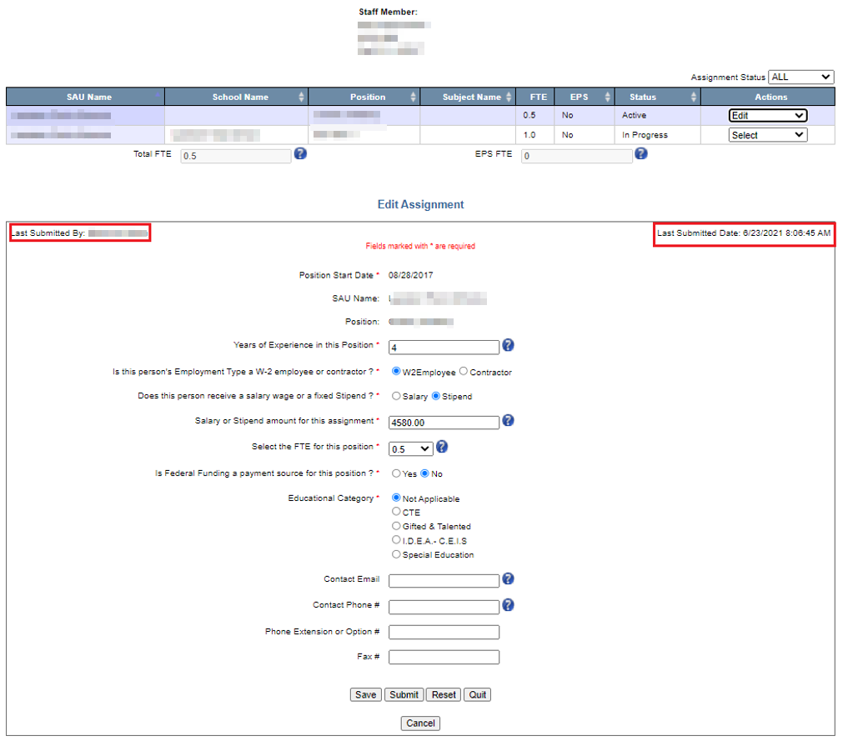

1. All the other functionalities are left unchanged at this time.

**Staff Certification:**

1. New column “Number of In Progress Position” is added to the grid.
   1. User will be able to certify the district positions given that there no in progress positions.
      1. If there’s at least one in progress position, the user will not able to certify the district positions and message will be displayed saying the same (refer image below for further details)
   2. All the other columns are functionalities remained the same at this time.

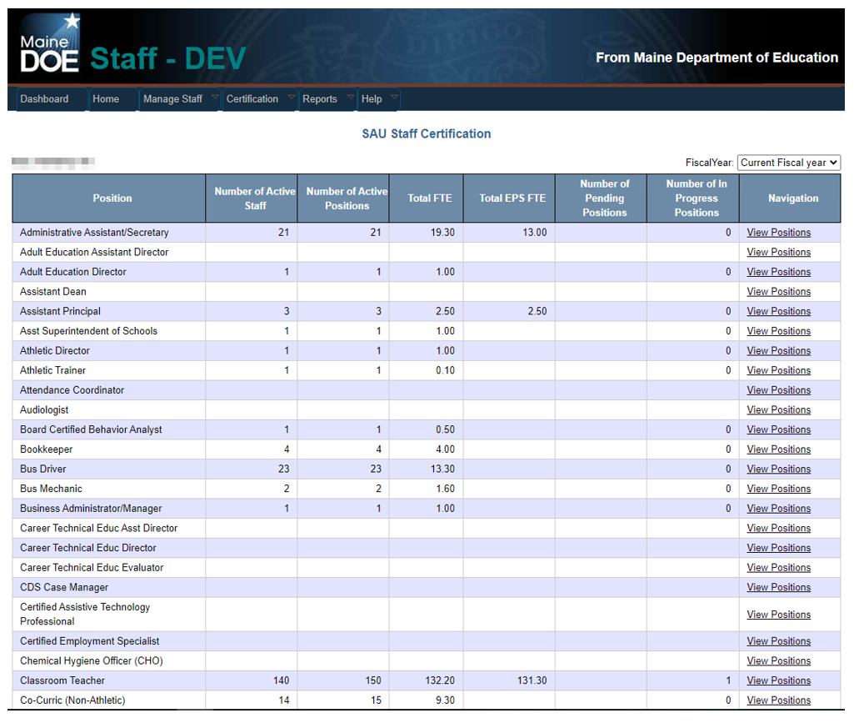

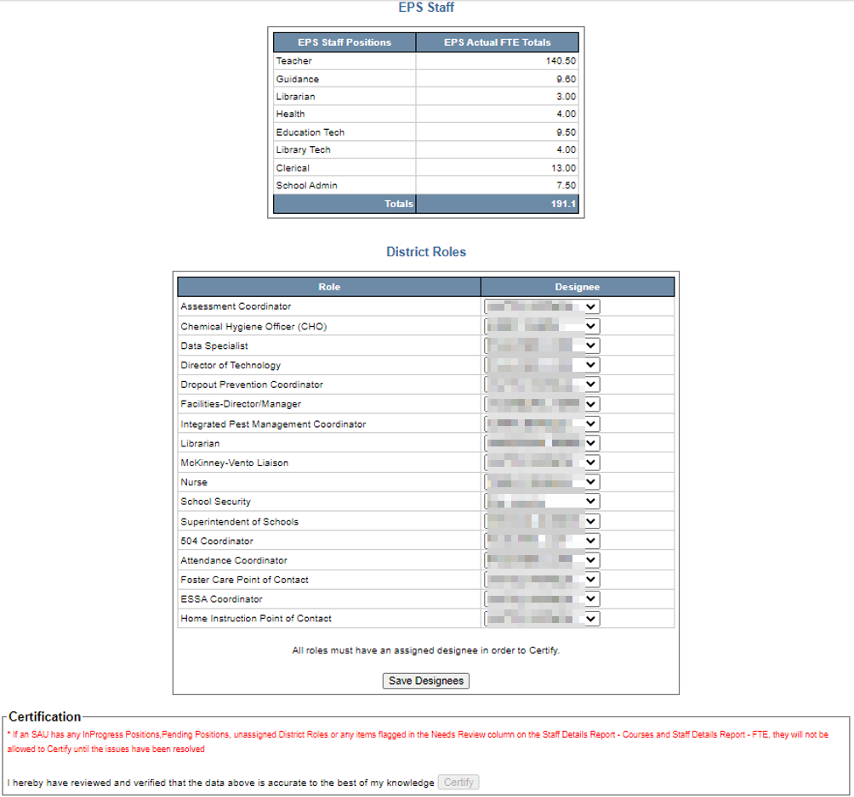

Staff Reports:

Created a new report named “Staff Details Report” which was created by merging the Staff Details Report – Courses and Staff Details Report – FTE.

